Appendix

Table . Logistic regression model results: coefficient estimates, model 2

|  |  |  |  |  |  |
| --- | --- | --- | --- | --- | --- |
|  |  |  |  |  |  |
|  |  |  |  |  |  |
|  |  |  |  |  |  |
| Predictor | β | *SE* β | z | *P>|z|* | (odds ratio) |
|  |  |  |  |  |  |
| Constant | -0.3616** | 0.129 | -2.805 | 0.005 | 0.697 |
|  |  |  |  |  |  |
| Anger | **0.6378**\*\*\* | 0.058 | 11.019 | 0.000 | 1.892 |
|  |  |  |  |  |  |
| Fear | **0.5730**\*\*\* | 0.117 | 4.912 | 0.000 | 1.774 |
|  |  |  |  |  |  |
| Happiness | 1.4265* | 0.629 | 2.267 | 0.023 | 4.164 |
|  |  |  |  |  |  |
| Sadness | **-0.5984**\*\*\* | 0.144 | -4.168 | 0.000 | 0.550 |
|  |  |  |  |  |  |
| NewsGuard score | -0.0025* | 0.001 | -2.024 | 0.043 | 1.000 |
|  |  |  |  |  |  |
| Aligned Party | **0.3598**\*\*\* | 0.061 | 5.898 | 0.000 | 1.433 |
|  |  |  |  |  |  |
| Ingroup words (log) | **0.5957**\*\*\* | 0.116 | 5.149 | 0.000 | 1.814 |
|  |  |  |  |  |  |
| Outgroup words (log) | **0.9417**\*\*\* | 0.115 | 8.224 | 0.000 | 2.564 |
|  |  |  |  |  |  |
| Happiness * NewsGuard Score | -0.0169* | 0.007 | -2.516 | 0.012 | 0.983 |
|  |  |  |  |  |  |
| Anger * Ingroup words (log) | **-0.6345**\*\*\* | 0.134 | -4.721 | 0.000 | 0.530 |
|  |  |  |  |  |  |
| Fear * Outgroup words (log) | -0.4711* | 0.215 | -2.195 | 0.028 | 0.624 |
|  |  |  |  |  |  |
| Aligned Party * Ingroup words (log) | 0.3692** | 0.118 | 3.122 | 0.002 | 1.447 |
|  |  |  |  |  |  |
| Aligned Party * Outgroup words (log) | **-0.6014**\*\*\* | 0.117 | -5.142 | 0.000 | 0.548 |
| Test | |  | χ2 | *df* | *p* |
|  | |  |  |  |  |
| Observations | 22,128 |  |  |  |  |
| Overall model evaluation |  |  |  |  |  |
| Likelihood ratio test |  |  | 963.17 | 13 | 1.415e-197 |
| Goodness-of-fit test |  |  |  |  |  |
| Hosmer & Lemeshow |  |  | 13.68 | 8 | 0.09 |
|  | |  |  |  |  |
| Note: | *p<0.05; **p<0.01; ***p<0.001 |  |  |  |  |

Table . Marginal effects of logistic regression model 2

|  |  |  |  |  |  |  |
| --- | --- | --- | --- | --- | --- | --- |
|  | dy/dx | std err | z | P>|z| | [0.025 | 0.975] |
| Anger | 0.1519 | 0.014 | 11.141 | 0.000 | 0.125 | 0.179 |
| Happiness | 0.3397 | 0.150 | 2.268 | 0.023 | 0.046 | 0.633 |
| Fear | 0.1364 | 0.028 | 4.922 | 0.000 | 0.082 | 0.191 |
| Sadness | -0.1425 | 0.034 | -4.174 | 0.000 | -0.209 | -0.076 |
| NewsGuard score | -0.0006 | 0.000 | -2.025 | 0.043 | -0.001 | -1.9e-05 |
| Aligned Parties | 0.0857 | 0.014 | 5.916 | 0.000 | 0.057 | 0.114 |
| Outgroup words (log) | 0.2242 | 0.027 | 8.272 | 0.000 | 0.171 | 0.277 |
| Ingroup words (log) | 0.1418 | 0.027 | 5.161 | 0.000 | 0.088 | 0.196 |

Table . Variance Inflation Factor for main independent variables in model 1

|  |  |
| --- | --- |
| Feature | VIF |
| Anger | 1.79 |
| Happiness | 1.97 |
| Fear | 1.37 |
| Sadness | 1.20 |
| NewsGuard score | 1.01 |
| Aligned Party | 1.00 |
| Neutral sentiment | 1.06 |
| Outgroup words (log) | 1.14 |
| Ingroup words (log) | 1.02 |

Table . Variance Inflation Factor for main independent variables in model 2

|  |  |
| --- | --- |
| Feature | VIF |
| Anger | 1.20 |
| Happiness | 1.07 |
| Fear | 1.13 |
| Sadness | 1.06 |
| NewsGuard score | 1.01 |
| Aligned Party | 1.00 |
| Outgroup words (log) | 1.11 |
| Ingroup words (log) | 1.02 |

1. DFBETA plots

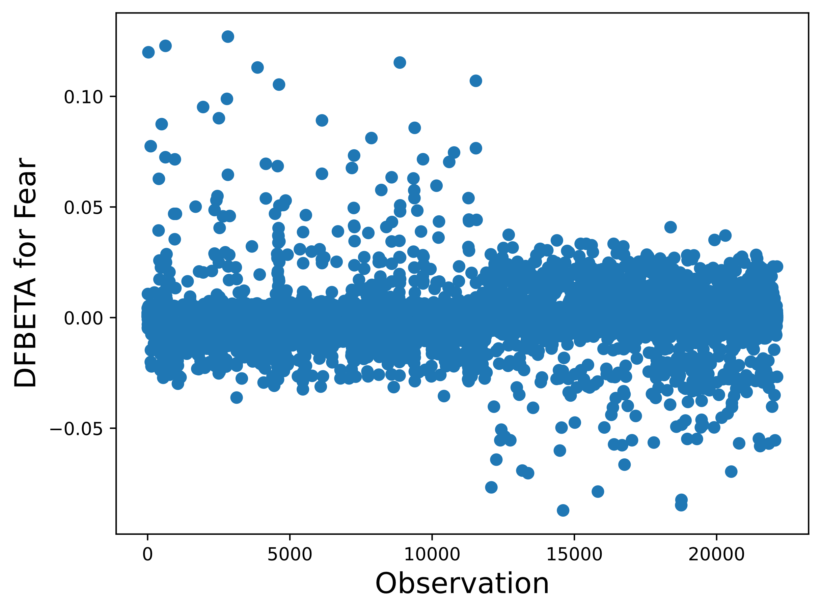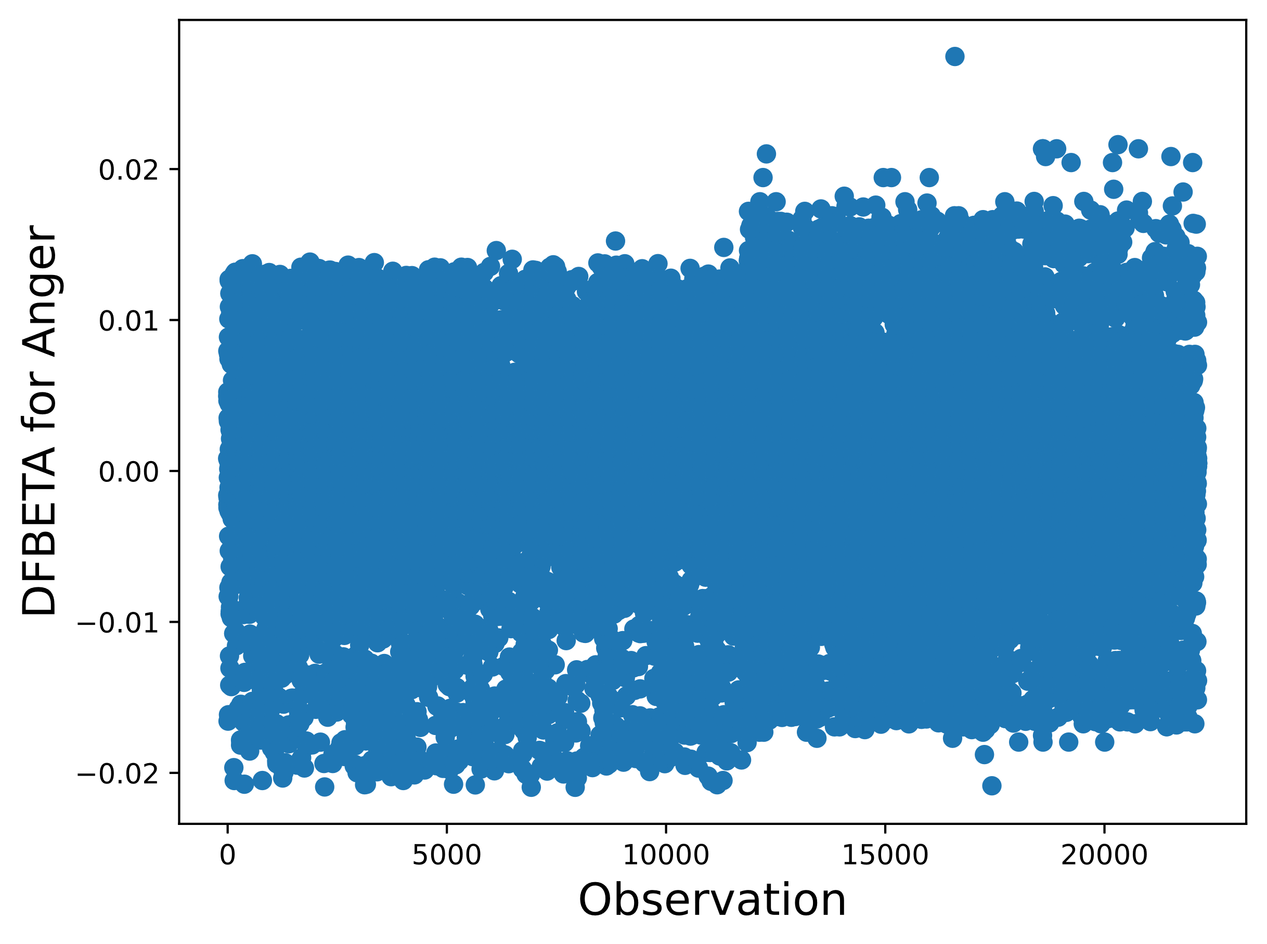

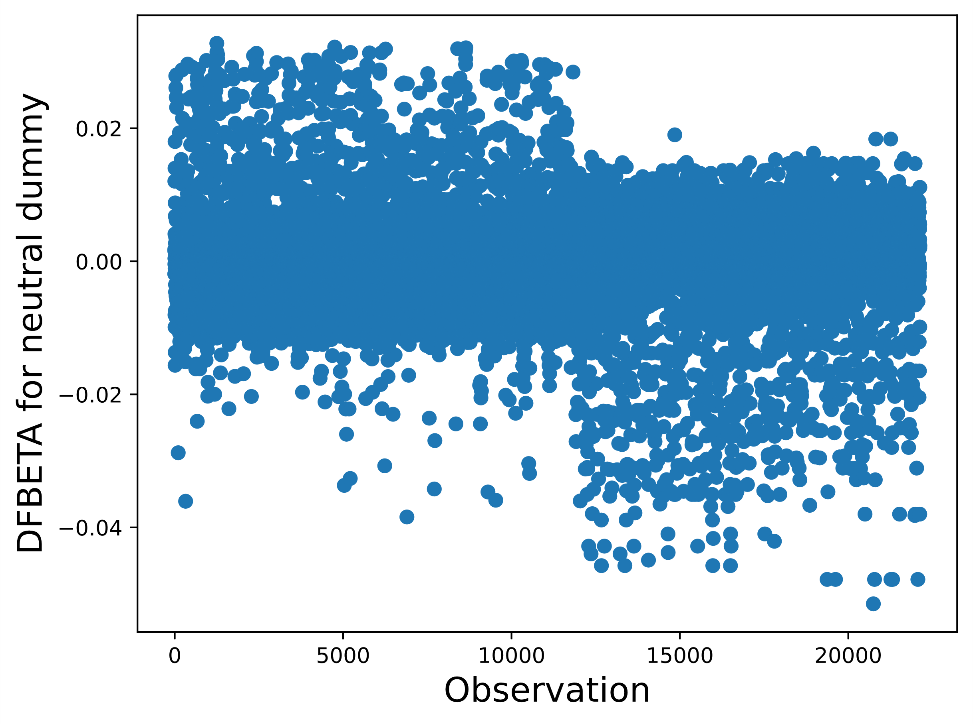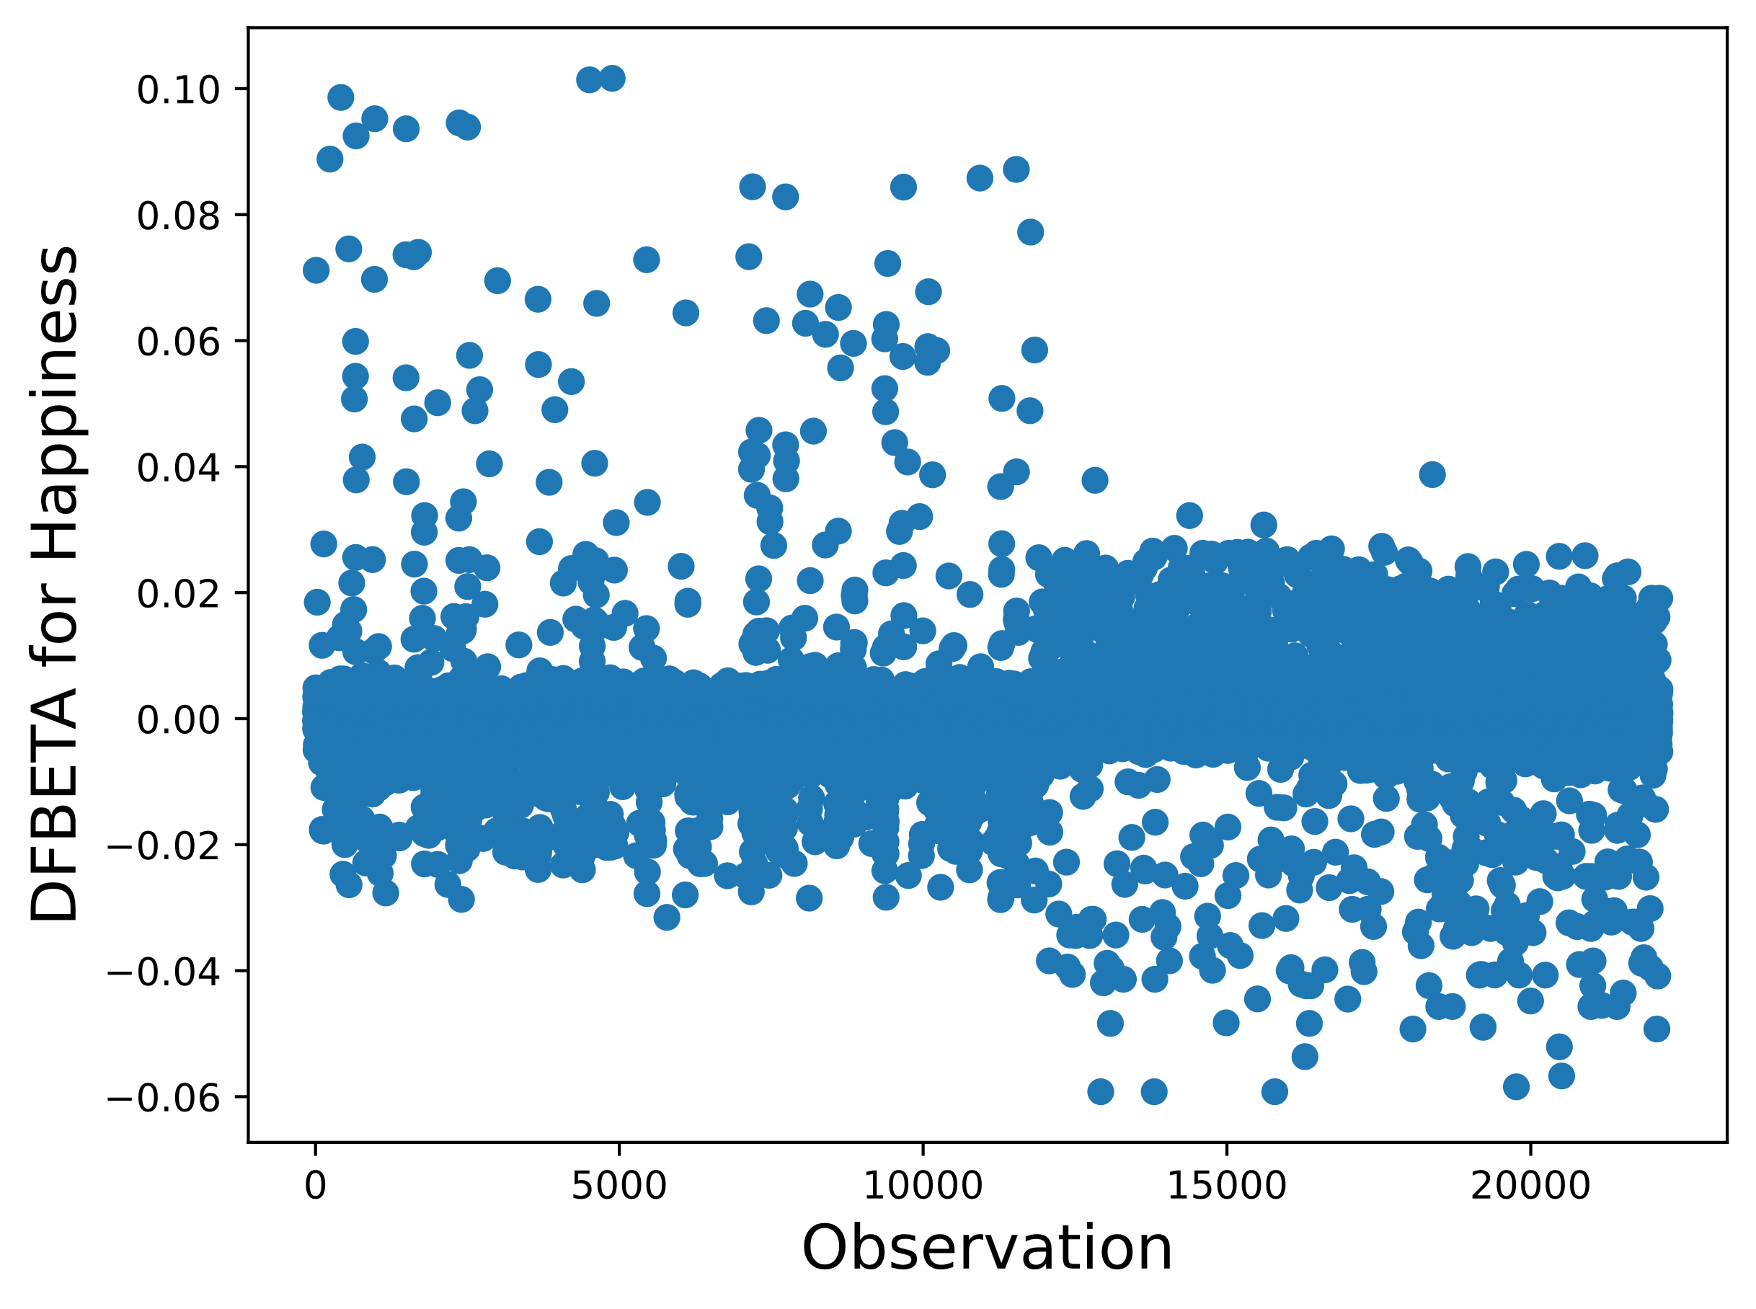

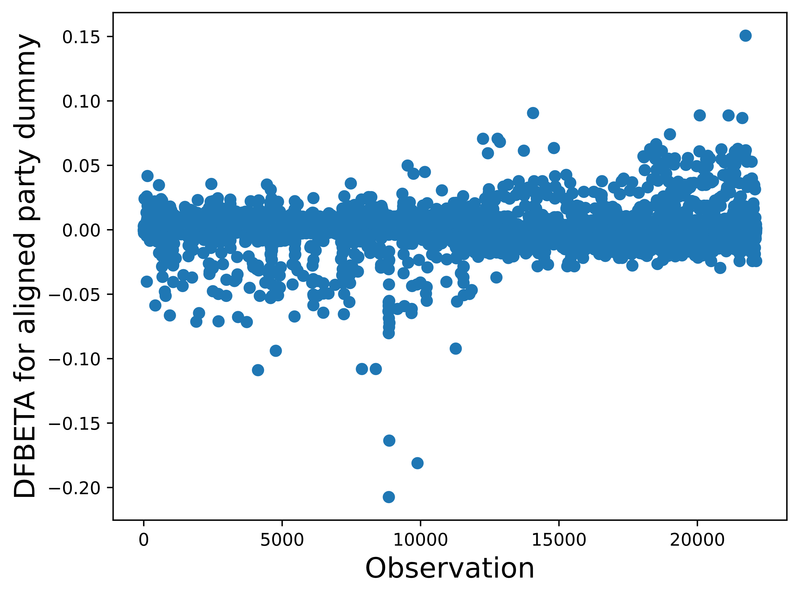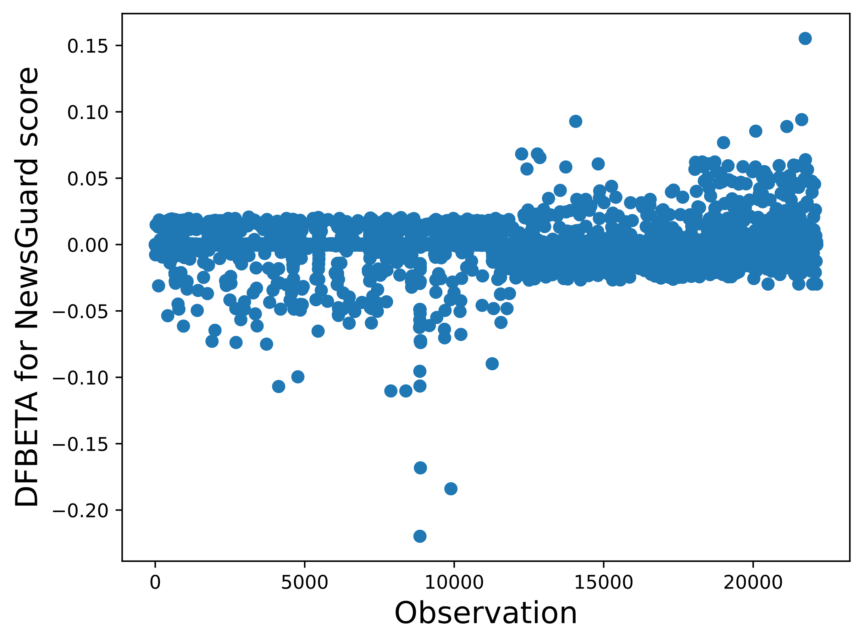

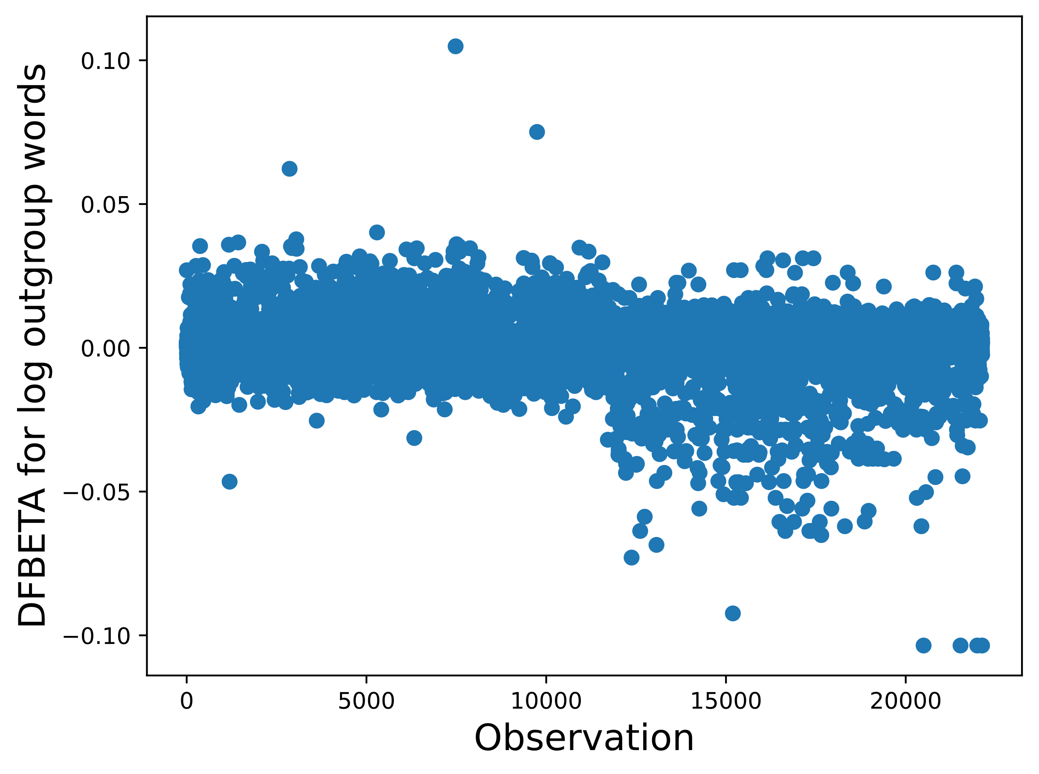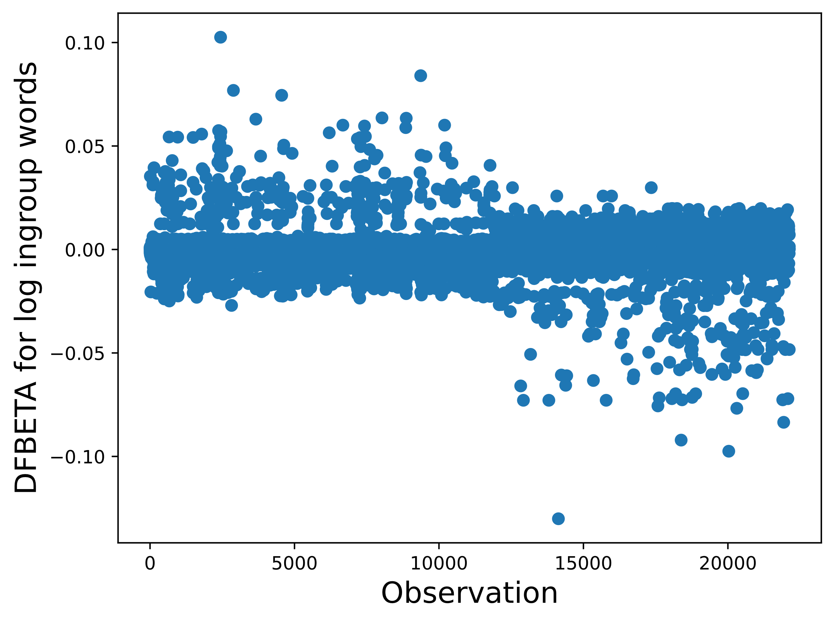

1. Predicted probabilities when varying anger

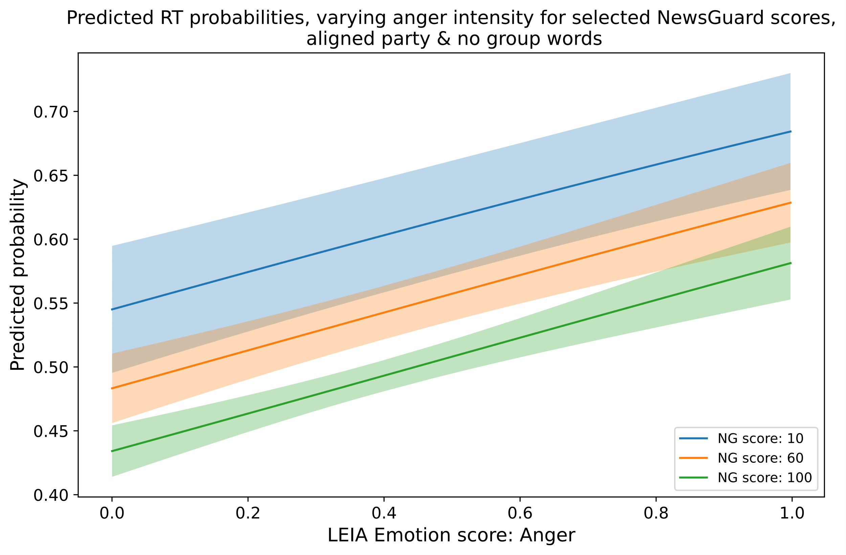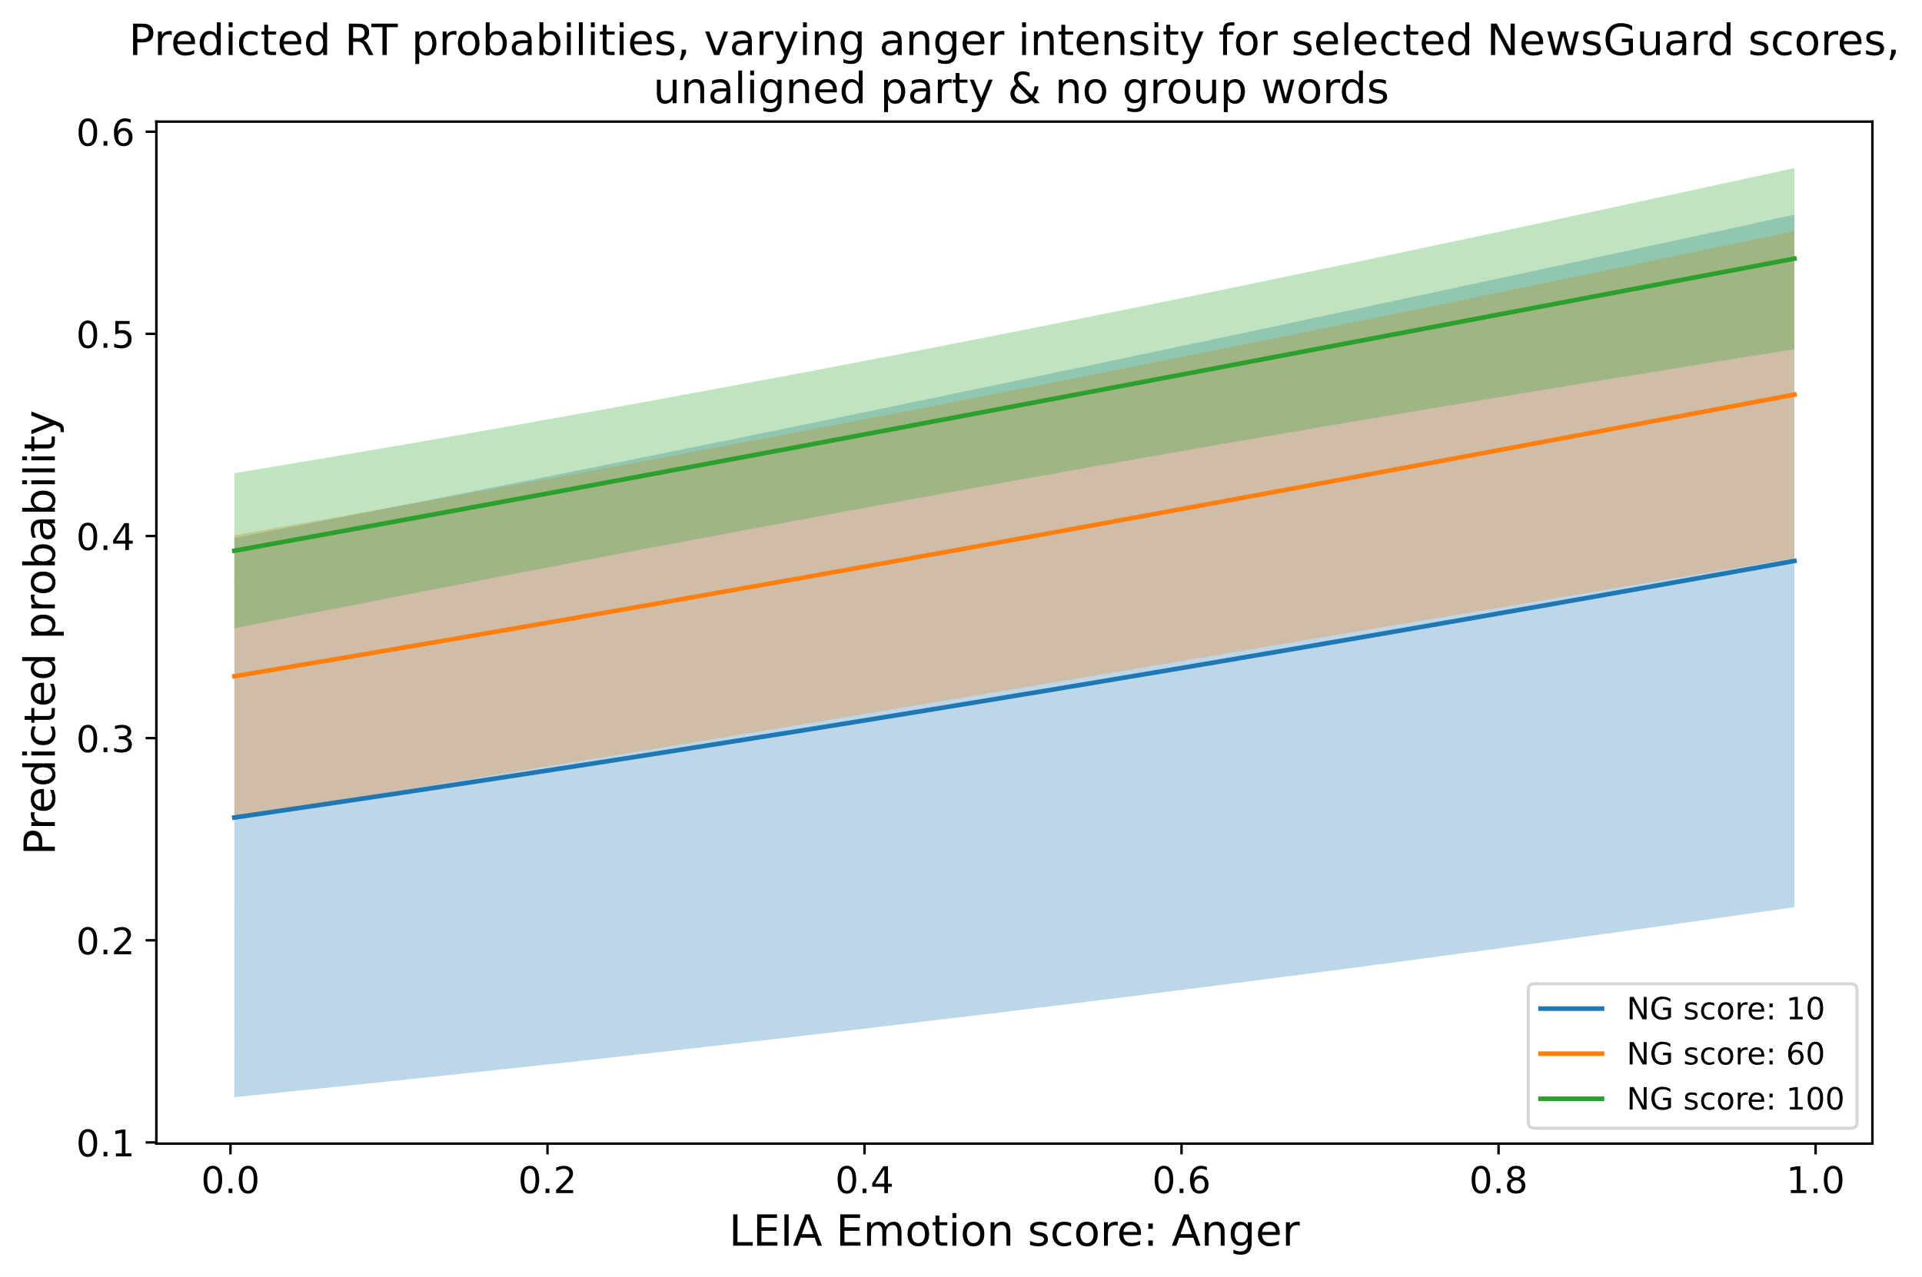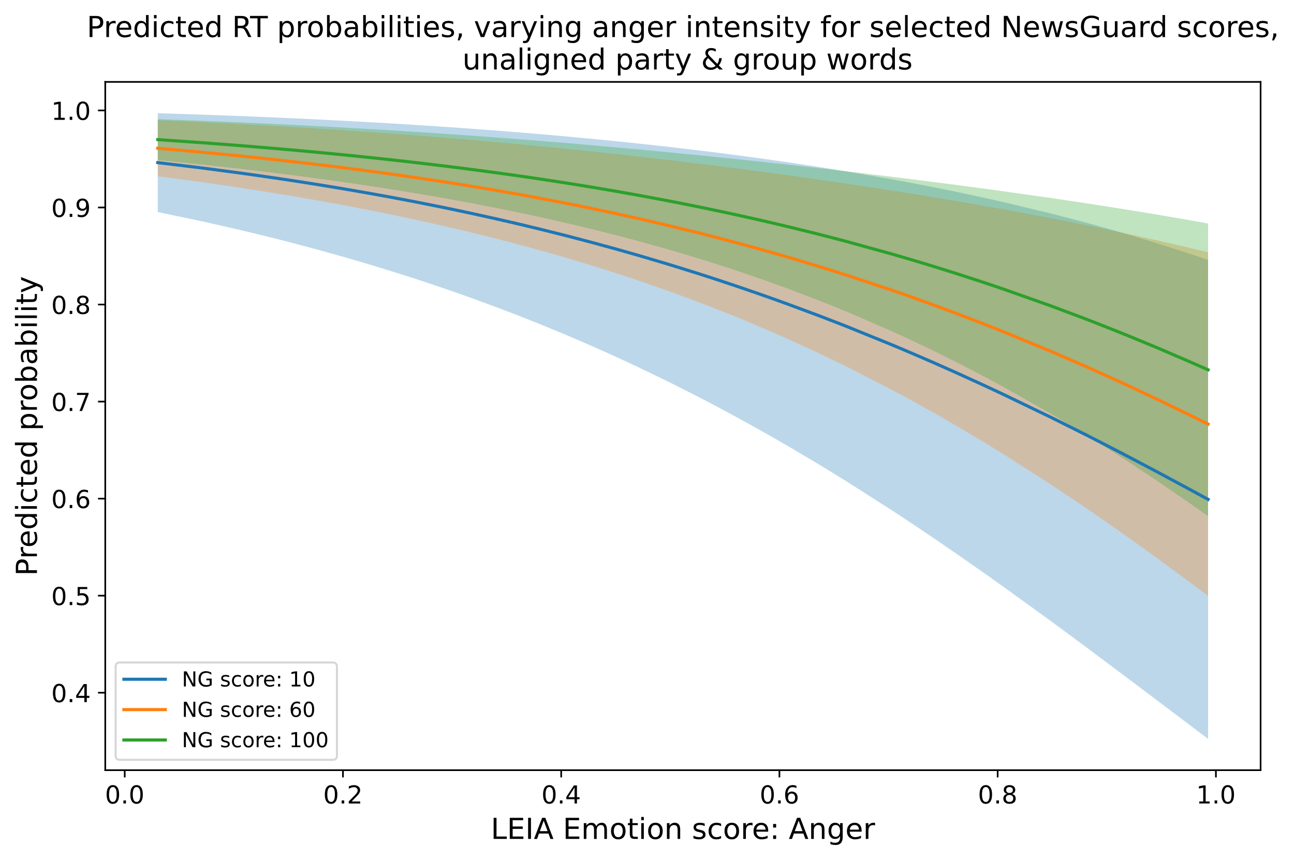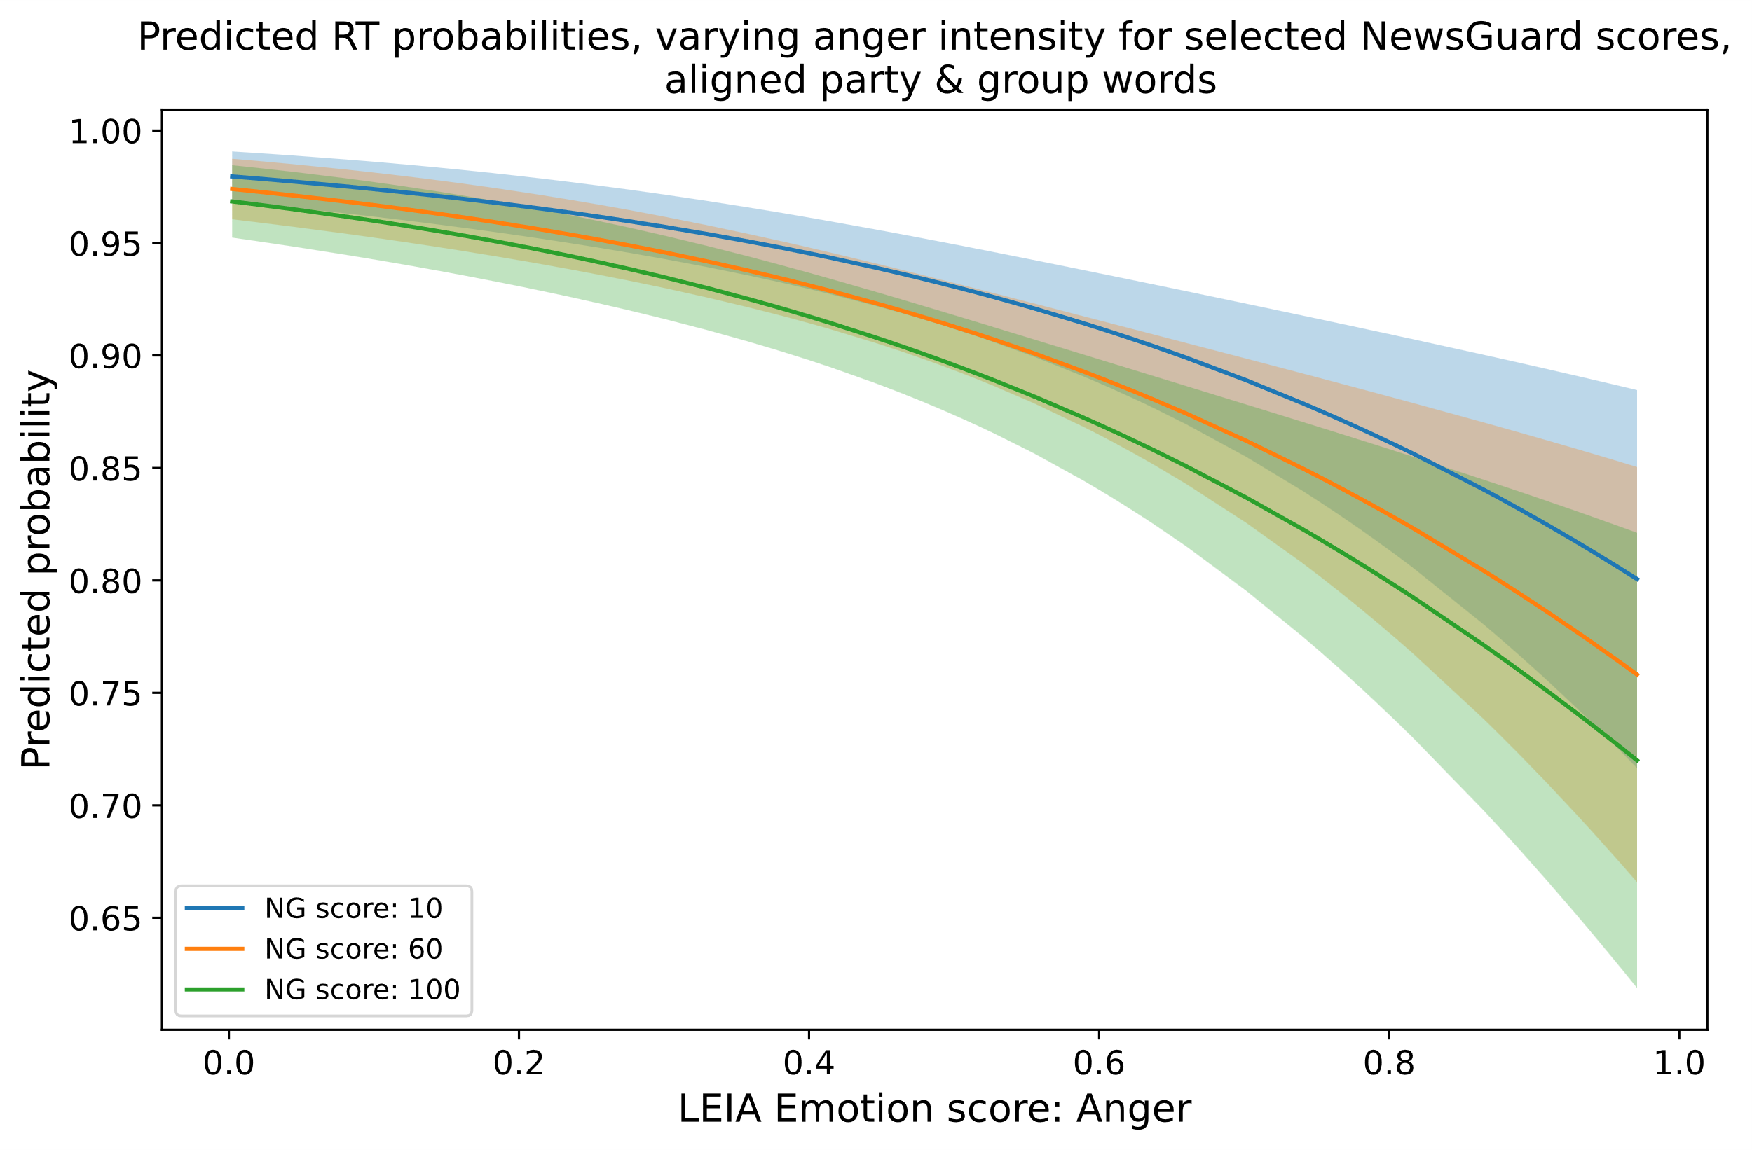

1. Predicted probabilities when varying happiness

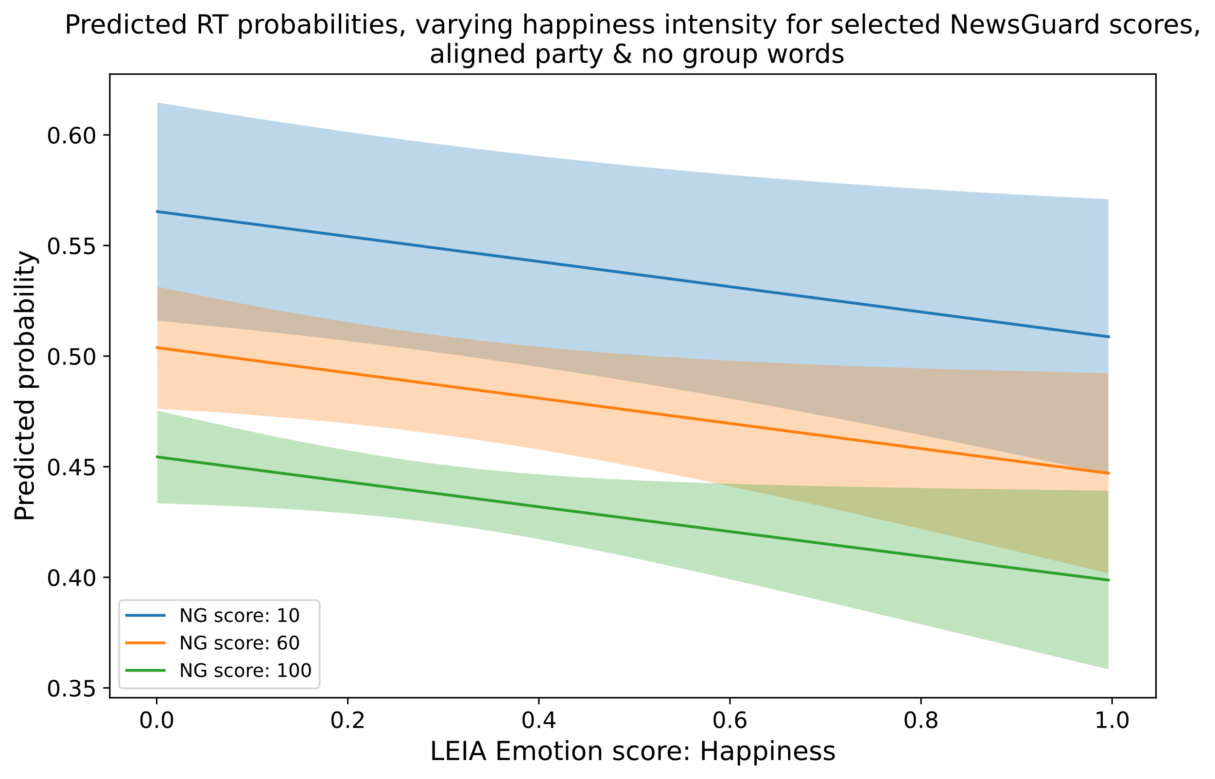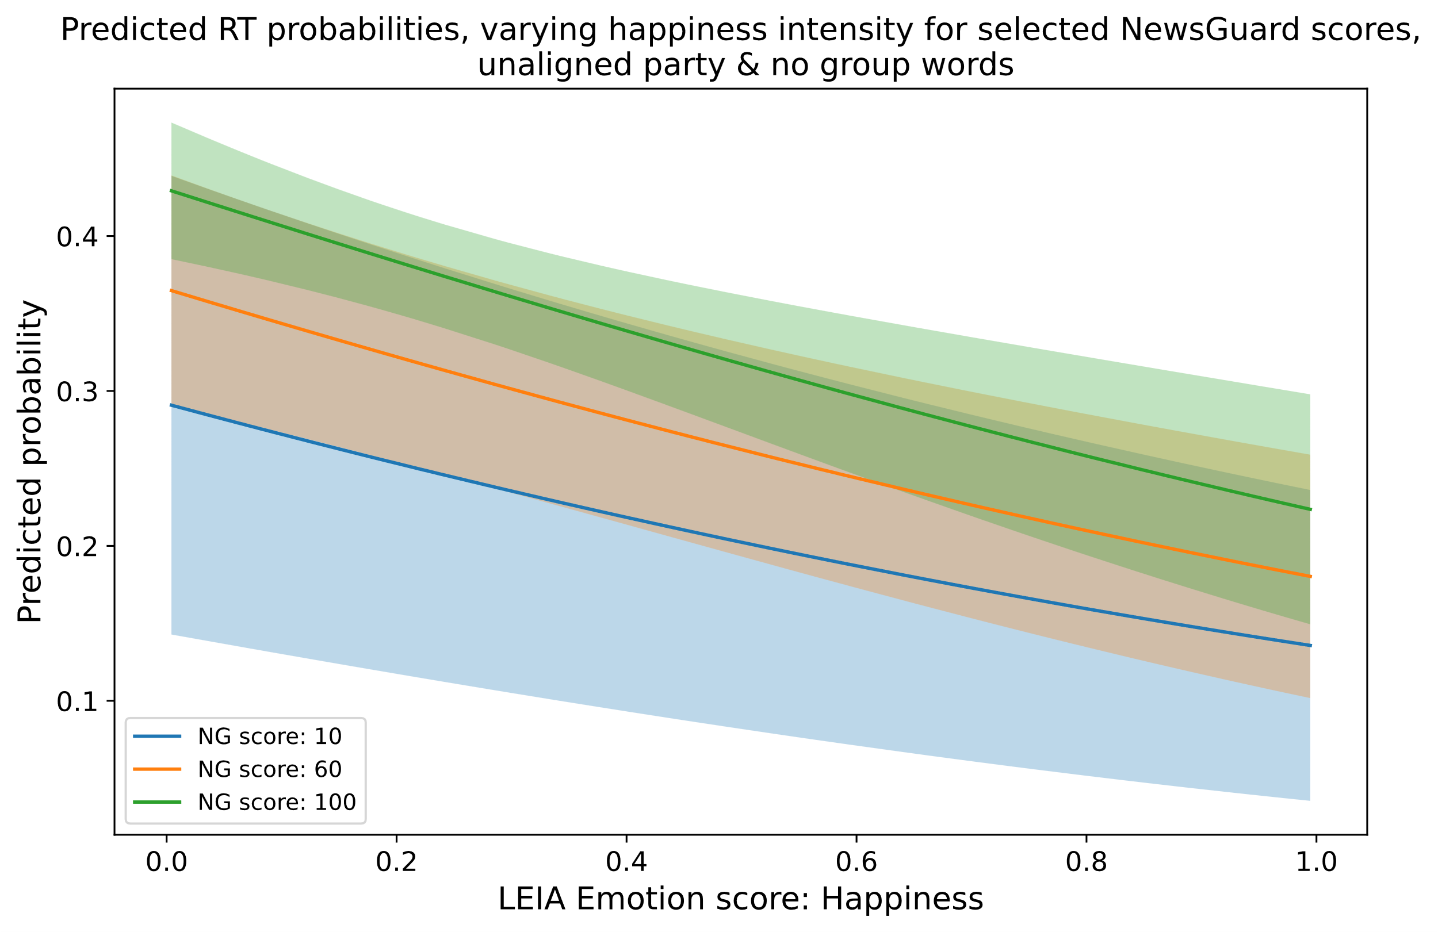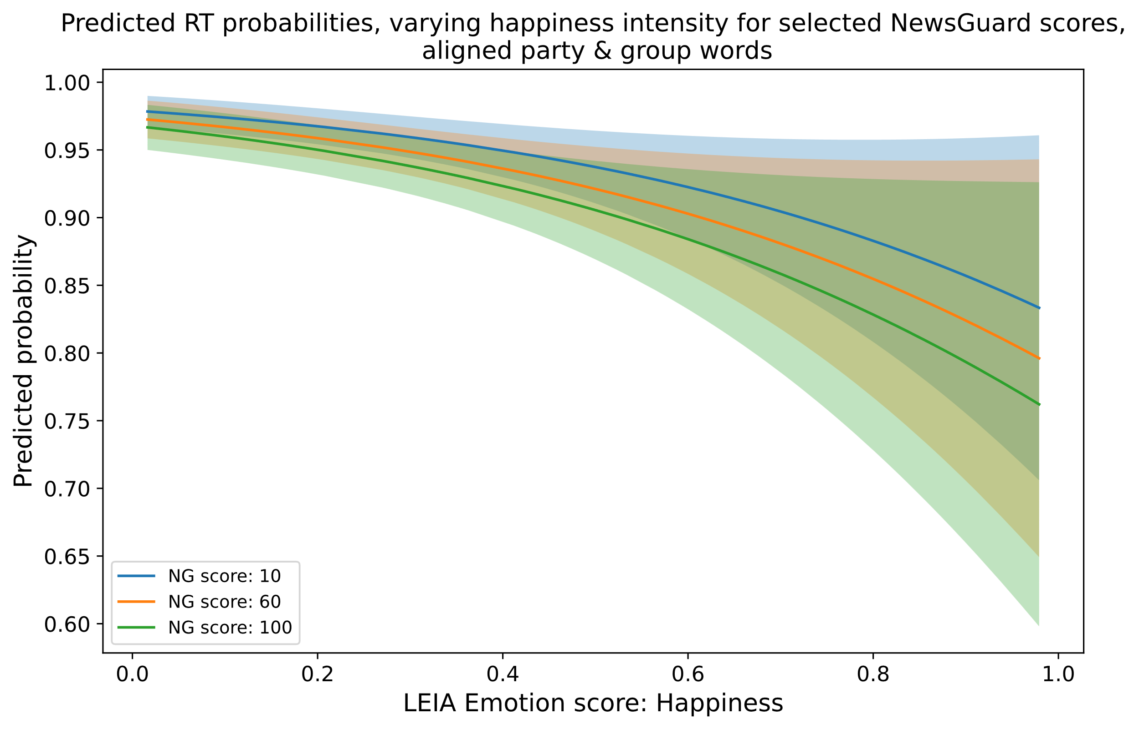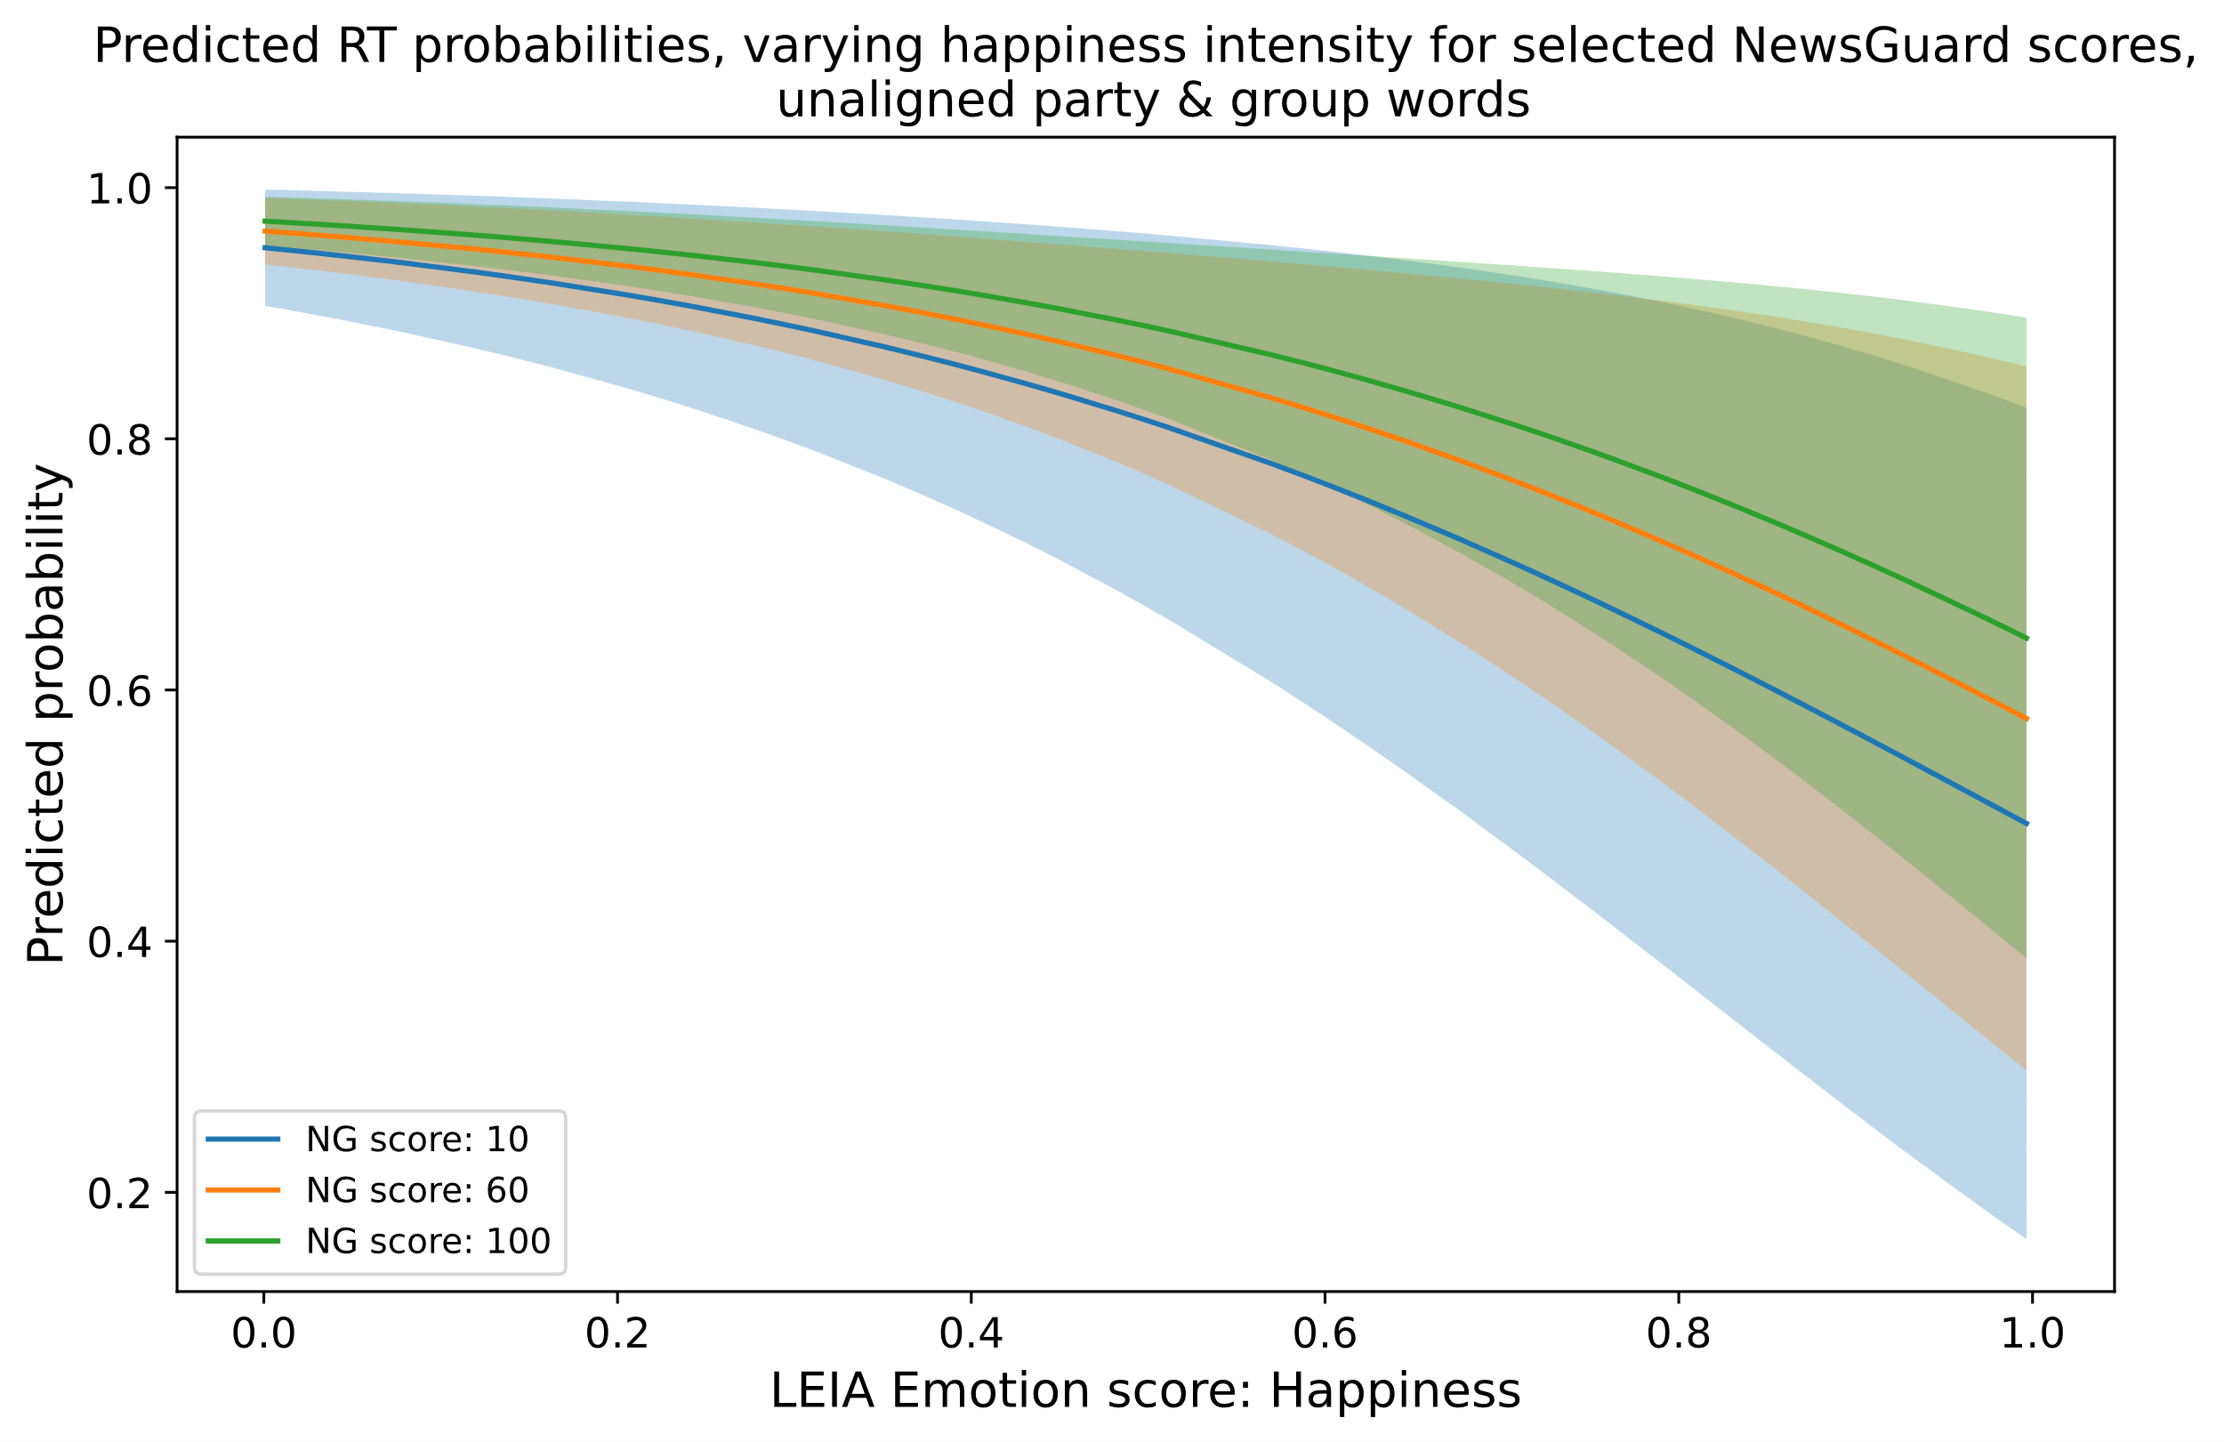

1. Predicted probabilities when varying fear

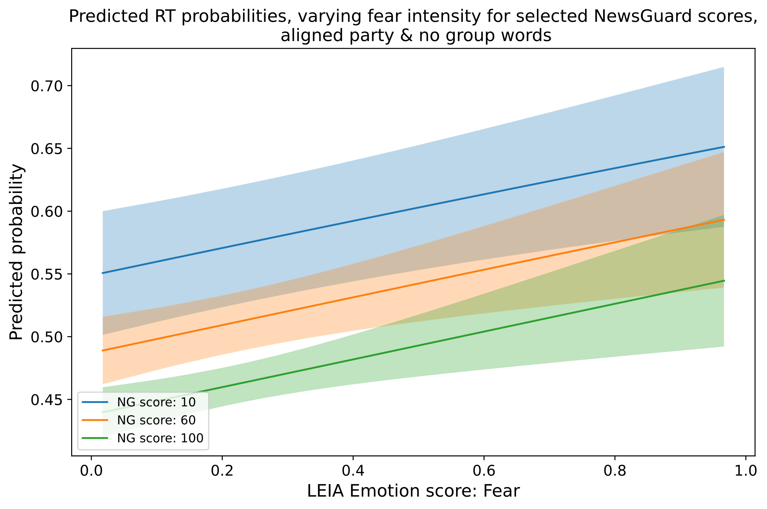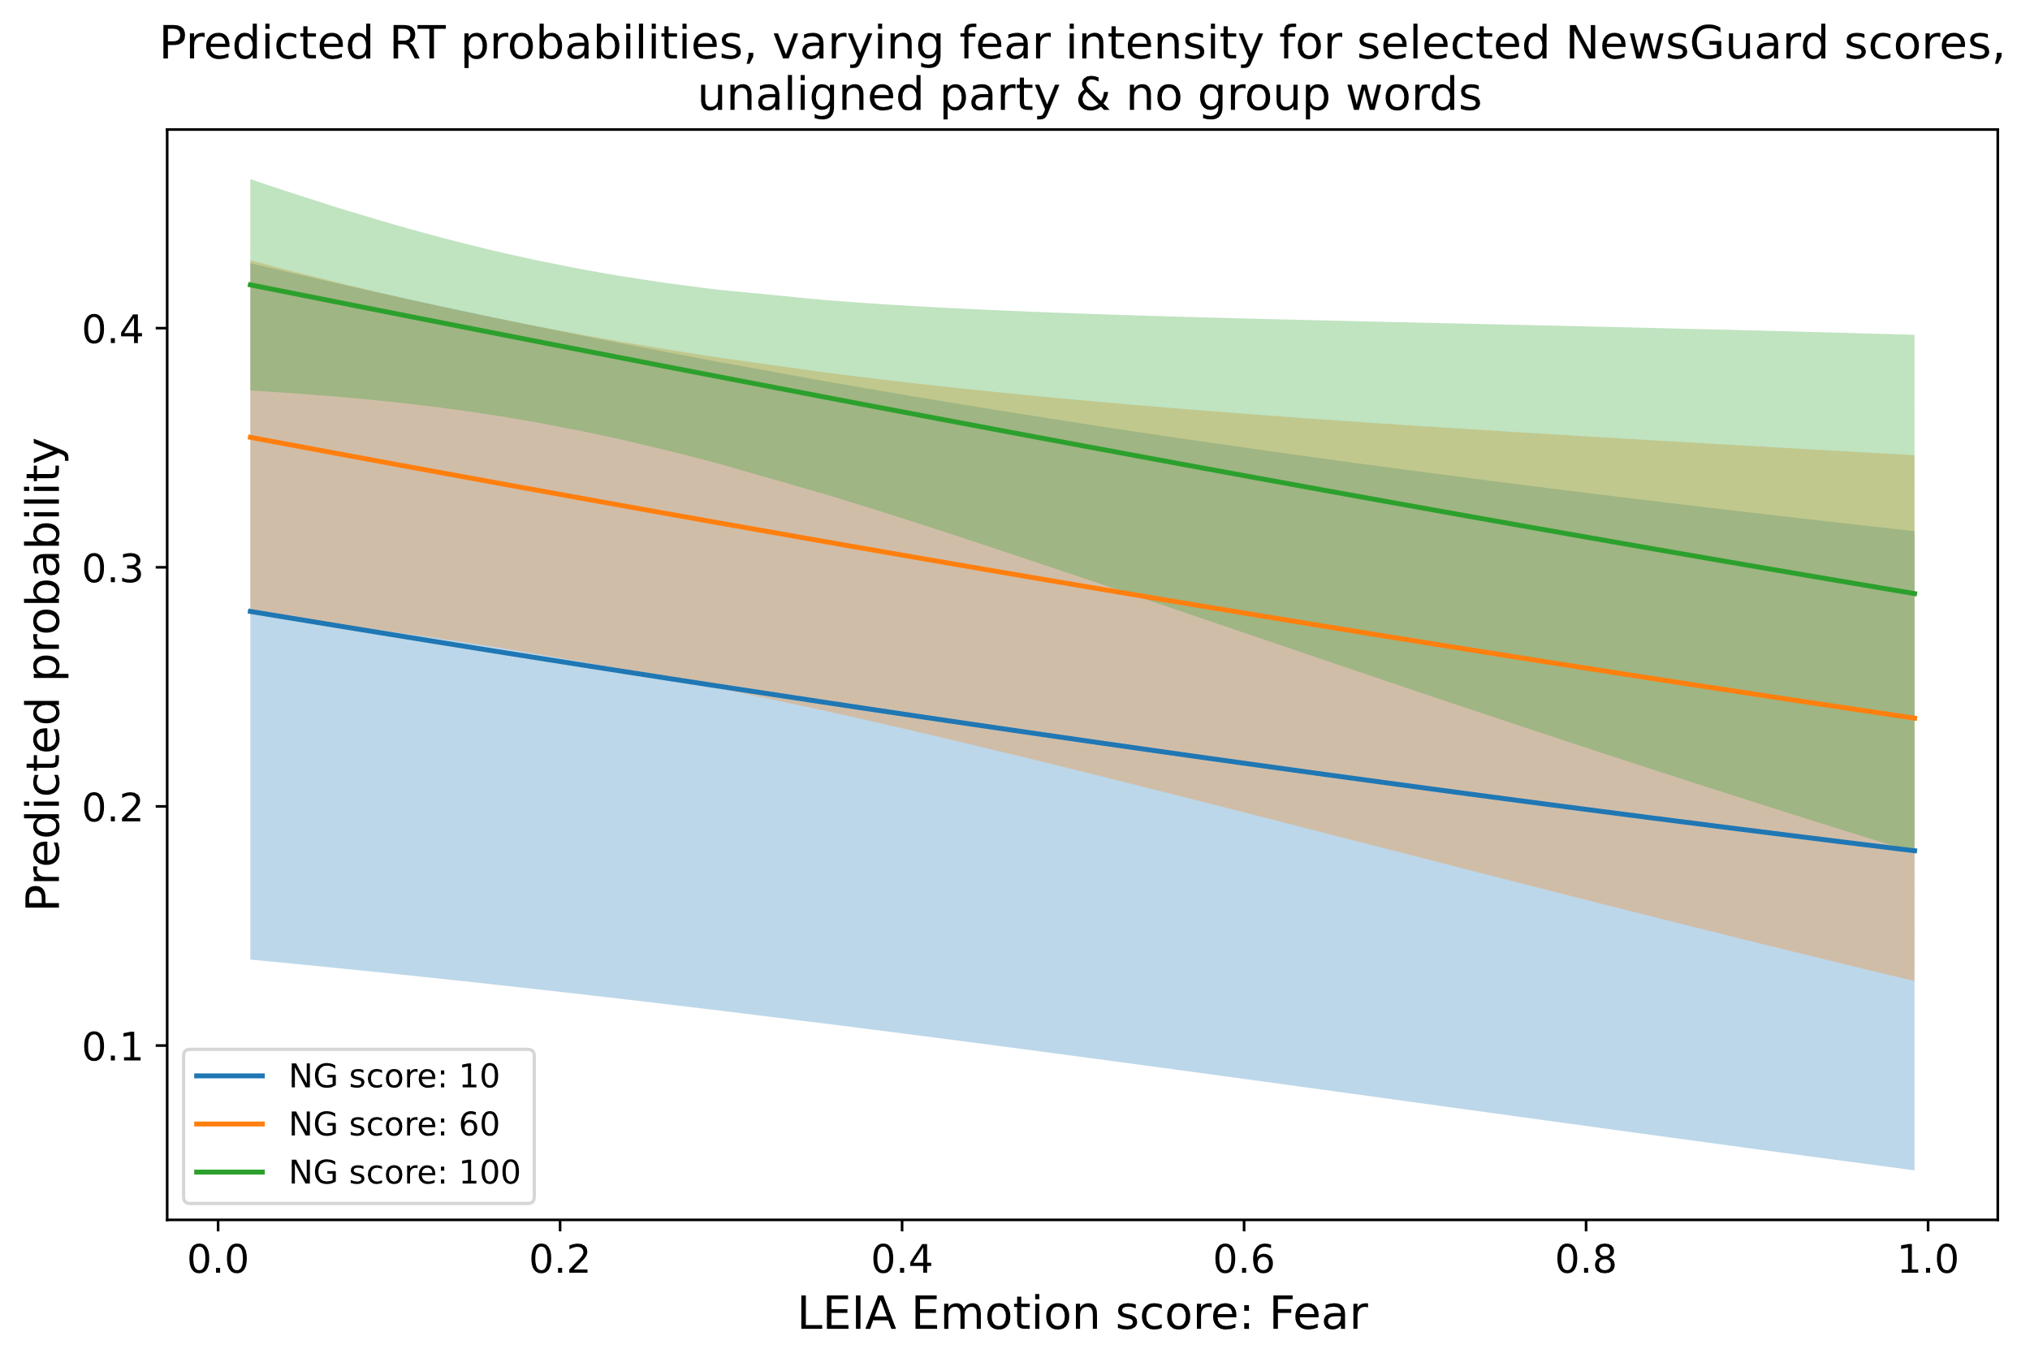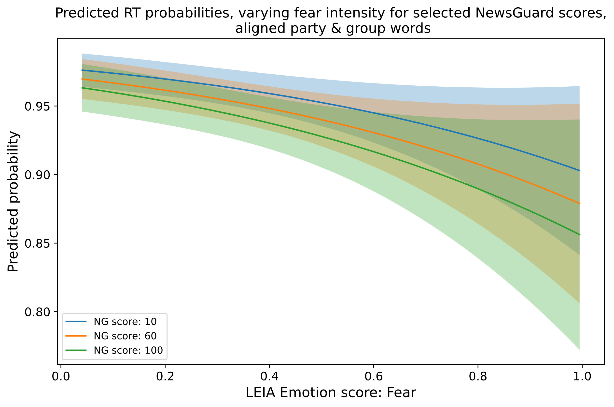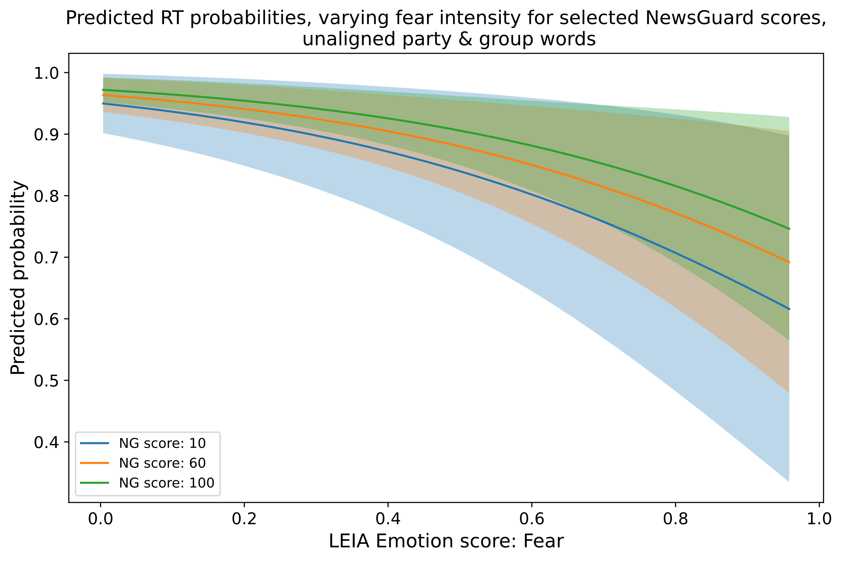

1. Predicted probabilities when varying sadness

